# Lab 12

Q1: Compute the linear Discriminant project for the two-dimensional dataset

Sample for class w1, X1=(x1,x2)={(6,3),(2,4),(6,5),(3,3),(4,4),(7,8)}

Sample for class w2, X2=(x1,x2)={(9,10),(7,9),(9,5),(8,7),(10,8),(10,10)}

Q2: We have dataset with 6×100-dimensional array. Create random dataset with 6 features and 100 number of samples, Apply PCA for dimension reduction, also compute the dimension of scatter or covariance matrix for this dataset.

Q3: Repeat Q2 with LDA 6×100-dimensional array for classification. 50 samples represent class1 and 50 samples represents for class2.

Q4: We have feature matrix for brain tumor dataset, Apply PCA for dimension reduction and classify this dataset with and without dimension reduction for any machine learning model as you studied before.

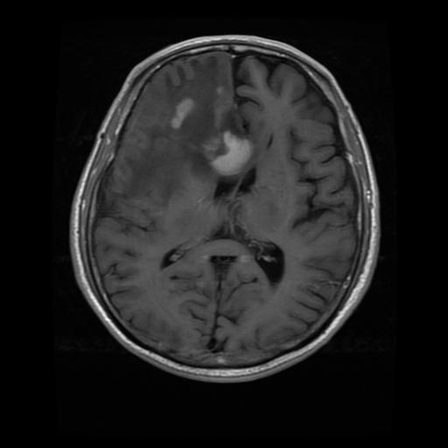

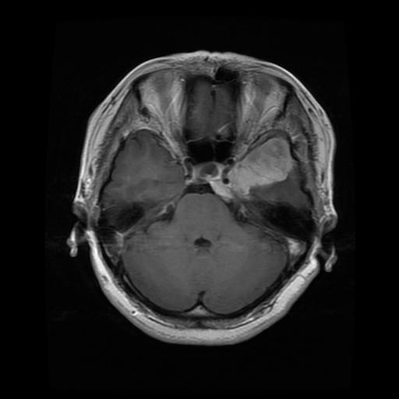

**Bag of visual words or other features**

|  |  |  |  |  |
| --- | --- | --- | --- | --- |
| Samples | F1 | F2 | fn | labels |
| 1 | -- | -- | -- | 1 |
| 2 | -- | -- | -- | 1 |
| … | -- |  |  | 2 |
| n | -- | -- | -- | 3 |

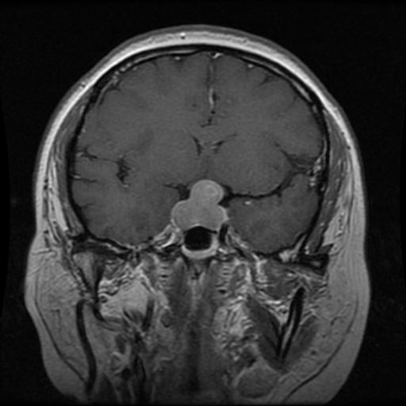

Split features into training and testing

Any classifier(RF,SVM,DT,KNN)

PCA for dimension Reduction

Q5: Repeat Q4 for LDA for classification (you can use sklearn libraray for LDA classification)